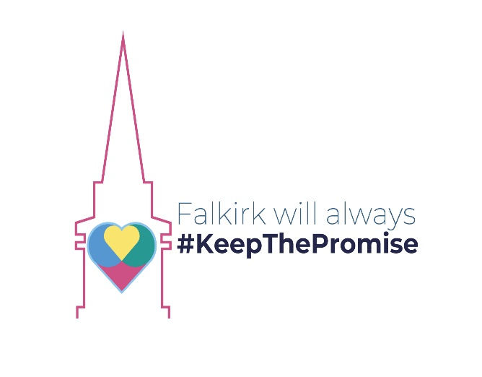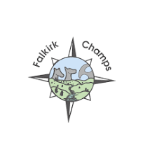

Falkirk Community Partnership Corporate Parent Plan 2024-2027

1. Foreword
Falkirk Family and Friends Corporate Parenting Plan outlines Falkirk’s roadmap and commitment to cover the period up to March 2027. The plan aims to improve outcomes for Care Experienced young people by aligning with the work of The Promise and focusing on six key areas. These six priorities were agreed upon in April 2024 and follow on from work undertaken across the partnership, looking at our strengths and areas for development.
The plan is underpinned by UNCRC (United Nations Convention on the Rights of the Child) and Children’s Rights and has been co-produced with Care Experienced children and families. We will continue to seek their participation and ongoing input in developing the plan and in monitoring and evaluation activities.
This plan is a continuation of Falkirk’s commitment to better serving our Care Experienced population.
As a proud and committed founding member of Falkirk’s Champs Board, I would like to thank all Falkirk Family and Friends for their effort and input into the ongoing development of this plan.
If you have any questions or would like to participate or discuss this further, please contact Falkirk Family and Friends via: promiseimplementationteam@falkirk.gov.uk
Cllr Cecil Meiklejohn
Chair of Falkirk Community Planning Partnership
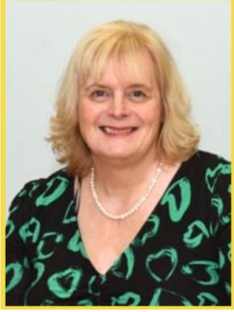

2. Introduction from the Falkirk Champs
We are very proud to be part of this Falkirk Family and Friends plan. We know that having a plan is an important step to making a difference and a change. We look forward to working alongside all our family and friends to make Falkirk the best it can be for the care-experienced community.
Love, The Falkirk Champs
#leaving a better care system behind us
Falkirk Champs

3. Who we are
This plan was produced jointly by the Falkirk Family and Friends team comprised of the following partners:
Police Scotland
Scottish Fire and Rescue Service
Skills Development Scotland
Falkirk Champs
NHS Forth Valley
Children’s Hearings Scotland
Falkirk Council Officers (representing Children and Families, Adult and Justice Social Work, Employability, Housing and Education)
Get to Focus Group (a group of local families who have had lived experience of Social Work interventions in their lives)
Third Sector
Forth Valley College
Promise Implementation Team
Scottish Prison Service
Scottish Children’s Reporter Administration
The work of the group was twofold-to complete the legal duties of being the Corporate Parents in Falkirk and to work towards implementing the Promise. We felt the two aims of these pieces of work joined up together nicely and were ultimately about the same thing: That of improving the traditionally poorer outcomes for care experienced people and helping all children in Scotland grow up loved, safe and respected.

4. Corporate Parent Duties and Who They Apply To
A Corporate Parent is an organisation that has special responsibilities towards Care Experienced children and young people. There are six duties as defined by law as laid out in Part 9 (Corporate Parenting) (Section 58) of the Children and Young People (Scotland) Act 2014:
Alert: Be alert to matters which may adversely affect wellbeing.
Assess: Assess the needs for the services and support we provide.
Promote: Promote the interests
Improve: Strive to improve the way it exercises its functions
Access: Take action to help access opportunities and support and make use of the services we provide.
Opportunities: Provide opportunities to participate in activities promoting wellbeing.

The Corporate Parenting duties apply to all looked after children (aged from birth to when they ceased to be looked after) and care leavers, who were looked after on or after their 16th birthday, up until the age of 26. This includes children looked after at home, in Foster Care, Residential and Secure Care, Formal Kinship Care and children with disabilities who are looked after on a series of short breaks. The Corporate Parenting duties apply equally to all categories of looked after children.

In short, Corporate Parenting seeks to help, advantage and benefit those with Care Experience. Corporate Parenting duties exist to be a "Good Parent" to looked after children and care leavers, to better the life chances of this group of young people and help these children realise their potential.

5. Who Are Our Corporate Parents?
Here is a list of all of Scotland’s Corporate Parents:
- Local Authorities
- Health Boards
- NHS National Services Scotland
- Scottish Ambulance Service
- Chief Constable of Police Scotland
- Scottish Fire and Rescue Service
- Scottish Ministers
- Scottish Children’s Reporter Administration
- Children’s Hearings Scotland
- Scottish Courts and Tribunals Service
- Scottish Prison Service
- National Convener of Children’s Hearings Scotland
- Commisioner for Children and Young People in Scotland
- Mental Welfare Commision for Scotland
- Scottish Housing Regulator
- Scottish Social Services Council
- Care Inspectorate
- Scottish Funding Council
- Skills Development Scotland
- Student Awards Agency for Scotland
- Scottish Qualificaions Authority
- Creative Scotland
- Scottish Sports Council (Sport Scotland)
- Highlands and Islands Enterprise
- Scottish Enterprise
- Social Security Scotland

6. The Promise Implementation Team
The Promise Implementation Team works across the Falkirk Community Partnership with a remit covering The Promise, Whole Family Wellbeing, Participation and Engagement, and Family Support. Scotland made a promise that all our children and young people would grow up loved, safe and respected, and realise their full potential. The team's aim is to embed a unified and humanised way of working that will be felt in day-to-day practice.
The Promise Implementation Team is only funded until 2026 but is working to embed a Promise keeping culture that will last. We have been building the foundations for collaboration between partners, young people, and families, rooted in relationship-based practice. We are striving for a trauma-informed, non-stigmatising way forward that can be shared and sustained.

7. Organisational Chart and Governance
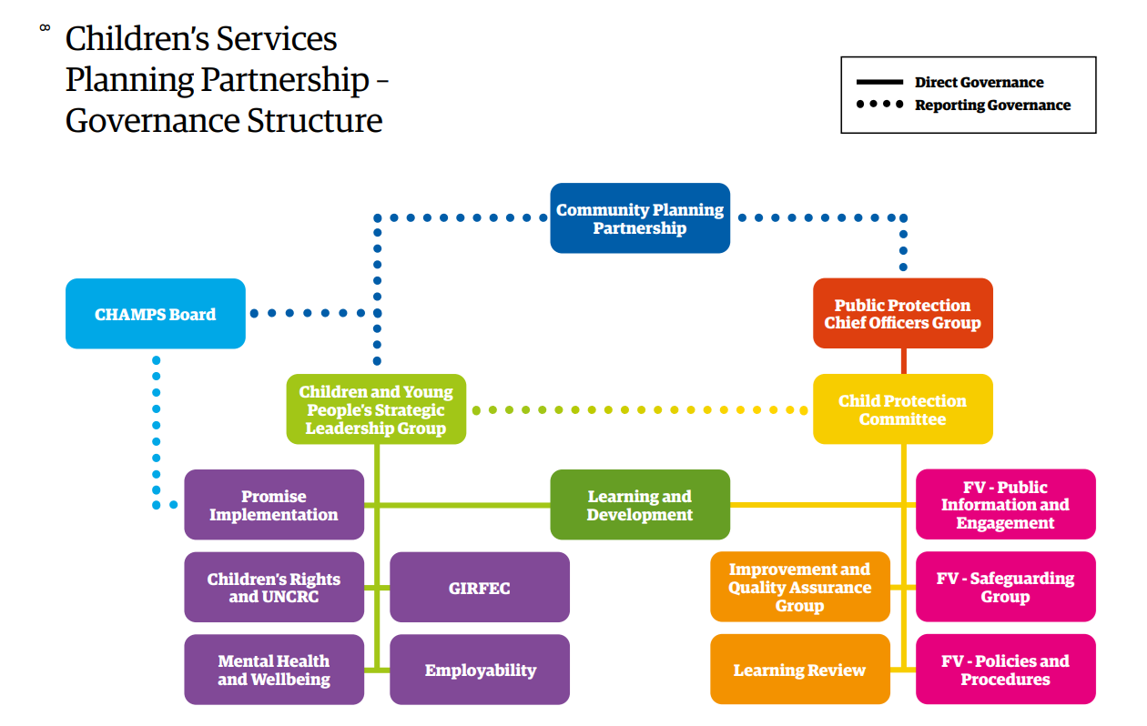

8. Why Do We Need Corporate Parents?
Children and young people are likely to be taken into the care system through experiences of abuse, trauma and neglect often collectively referred to as Adverse Childhood Experiences (ACEs). ACEs include parental substance misuse, physical or emotional abuse, neglect, parental mental illness, or a parent in prison. Children with Care Experience tend to have poorer outcomes in life as a result of their early life trauma.
The exclusion rate for looked-after pupils in Scotland was more than six times the rate for all pupils in 2020/21. In Scotland in 2020/21, 37% of school leavers who were looked after within the year left school in S4 or earlier, compared to 11% of all school leavers.
Care Experienced adults are twice as likely to have experienced homelessness, usually before their 30th birthday
Around 40% of young people in custody report that they have been in care. There is no evidence that Care Experienced children engage in more offending behaviour than their peers, but the consequences of their behaviour whilst in care are much more likely to result in criminalisation.
Corporate Parenting was introduced to tackle the persistently poorer outcomes for people with Care Experience and do the things that any loving and nurturing parent would do to help their children progress in life and realise their potential.

9. How We Got To Where We Are Now
Who had input to the plan and how it was developed Mapping Tool gap analysis/ logic model completed with FFF.
- Jan 2023: Recruitment to the Promise Implementation Team begins
- June/ July 2023: Corporate Parent Group membership revitalised with meet and greet events held and new Terms of Reference written for our Corporate Parent Group
- August 2023: First Corporate Parent Group meeting under the stewardship of the Promise Implementation Team held
- October 2023: Champs successfully lobbied to change our name to Falkirk Family and Friends. Work on the Corporate Parent Plan began
- December 2023: Falkirk Family and Friends had completed a Logic model which was the starting point of setting out our plan's priority areas
- Feb 2024: Draft Corporate Parent Plan Priorities presented to Falkirk Family and Friends
- April 2024: Corporate Parent Plan Priorities agreed
- September 2024: Workforce Survey deployed across the partnership

10. How we measure our impact
When we started our work in the Promise Implementation team there were no standard national metrics with regards to charting progress in our work of implementing the Promise and improving outcomes for looked after children and care leavers. With the help of Mike Richardson from the National Development Team for Inclusion, metrics were chosen which help us monitor what is important for good outcomes over the course of people's lives. Collectively these metrics are known to us as our Promsie metrics and help us have oversight of important outcomes such as educational attainment and positive destinations for school leavers.
Our Corporate Parent plan has six priorities. These were settled on primarily through three routes. The first was through one-to-one meetings with Corporate Parent Leads across the partnership with the Promise Implementation Team. These discussions began to build up the ‘As is’ picture across the partnership with regard to awareness of the Promise and Corporate Parent Duties with each Corporate Parent.
The second route was through partners completing Promise Excel sheets (see Appendix 2) pertaining to Workforce priorities of Plan 21-24. A gap analysis was then completed on these responses to establish where we may wish to start our work.
The third route was another collaborative effort and that was completing a Logic Model (see Appendix 1) with partners to begin to think about our desired endpoint in the partnership and what we would need to do to get there. All three streams of work combined together to form the six priorities you see in our plan.

11. Falkirk Family and Friends Definition of Care Experience
Unlike Corporate Parenting, the term Care Experienced has no basis in statute. Nor is there an agreed term nationally. The Promise Scotland has asked the Scottish Government to look into this but in the meantime, Falkirk Family and Friends forged ahead and defined and agreed on their own definition as follows:
“The term care-experienced in Falkirk refers to anyone who has been or is currently in care or from a looked-after background at any stage in their life, including adopted children who were previously looked-after. This care may have been provided in one of many different settings such as in residential care, foster care, kinship care, or through being looked-after at home with social work support.”

12. Looking Back On Previous Achievements
There have been many achievements that have come to pass that were once action points in our previous Corporate Parent Plan 2022/23. Some of the achievements from that Plan are listed here:
- Promise Implementation Team was established and reached its full complement of staff in 2023. The team had oversight of the Promise, Family Support, Corporate Parenting and administering funds on behalf of the Whole Family Wellbeing Fund (WFWF)
- New Terms of Reference were drawn up for the Corporate Parenting Group
- A revamped Corporate Parenting group, now known as Falkirk Family and Friends is now in place
- Falkirk Champs successfully lobbied the council to have Care Experience as a protected characteristic
- A Trauma Informed Policy Officer is now in place to inform practice and policy changes to ensure Falkirk Council becomes a Trauma Informed organisation
- A Learning Development Strategy and Staff Handbook were developed that assisted the workforce to feel connected to the wider strategic priorities of the partnership

13. Our Looked After Children and Care Leavers
The following tables give a snapshot picture of the current numbers of looked-after children in Falkirk as well as placement type. Information is also included for Care Leavers.
No. of looked after children in Falkirk vs Scotland (rate per 10,000 0-17 population), 3rd April 2024
Falkirk | 109
Scotland | 118
No. of looked after children by placement type, 3rd April 2024
At Home | 94
Kinship Care | 86
Foster Carers - LA | 70
Foster Carers - External | 39
In Local Authority Home | 7
Residential Care - External | 44
Total | 340

For the table in orange below, a Compulsorily supported person is a young person for whom the local authority has a duty to provide support and assistance under Section 29 (1) of the Children (Scotland) Act 1995. This young person has ceased to be looked after but is under 19 years of age. A Discretionary supported young person is a young person who the local authority has agreed to support under Section 29 (2) of the Children (Scotland) Act 1995 (as amended) up to age 25.

Eligible for Aftercare, 29th May 2024
 | Total | In Receipt
Aftercare - Compulsory | 28 | 20
Aftercare - Discretionary | 227 | 61

14. The plan priorities
Priorities | Desired Outcomes | Actions | Who is Responsible? | Progress
1) A Supportive Workforce who understand and buy into their Corporate Parenting Duties and are Trauma Informed | Corporate Parenting training rolled out to all Falkirk Family and Friends to ensure awareness of and commitment to their legal duties.  Trauma Informed staff | Multiagency Training Officer and Falkirk Champs make training, learning and development opportunities available to all Falkirk Family and Friends  Roll out of Promise Award in schools. | Organisational Development and Falkirk Champs  Care Experienced Attainment Lead | Baseline position to be reported back to Falkirk Family and Friends from Learning and Development with regard to who has undertaken the training.  Started
2) Maintaining and encouraging caring and compassionate values across the partnership workforce | Development of values that are Trauma Aware. Think not ‘Whats wrong with you?’ but ‘Whats happened to you?’ We want to instil the ethos of ‘Treat us like your own’ across the workforce. The value of ‘Stickability’ has been raised before by the group. | Each subgroup to take responsibility for developing values to be adopted by the workforce.  Develop a values charter to be embedded across the partnership. | Falkirk sub-group Leads  Forth Valley College | To be started  To be started
3) Voice | We will prioritise children and families' participation in co-designing, delivering and monitoring our services. | Create the conditions for meaningful participation and collaboration between local children and families in decision making forums across the partnership.  Embedding participation into partnership structures and governance from the start. | Health and Participation Representatives | To be started
4) Securing positive educational outcomes for looked after children and care leavers.  Increasing the number of care leavers in education, training and employment. | Improved attainment for Care Experienced pupils in numeracy and literacy.  Clear and consistent recording and review of non-attendance and part-time/ flexible timetables across all schools.  Increased numbers of Care Experienced Pupils who leave school with qualifications.  Increased attainment of Care Experienced students at college.  Providing relationship-based support to those furthest away from the job market.  To increase the number of Care Experienced people in positive destinations (Education, training, volunteering, apprenticeships) | Report and monitor attainment through Promise Metrics.  Monitor when Care Experienced pupils leave school.  Report and monitor attainment through Promise Metrics  Forth Valley College data on Care Experienced Pupils.  Establishing and sustaining a Falkirk Family Firm approach.  Increased engagement with Care Experienced people.  Measure changes and improvements to services and supports on feedback loop of those with Care Experience | Care Experienced Attainment Lead  Care Experienced Attainment Lead  Care Experienced Attainment Lead  Forth Valley College  Promise Lead  ETU | Started  To be started  ongoing  May 2024  December  2024  Focus groups and lived experience panels have been established and continue to shape service design and delivery
5) Ensuring physical and mental health concerns are identified early and addressed quickly. | Mental health supports are prioritised and accessible for Care Experienced people and waiting times are reduced. | Active monitoring and reporting on waiting times for all mental health services in Falkirk. | Health Representatives | All Falkirk mental health services to be mapped out with the help of Gill Campbell. Waiting lists can then be obtained from there and reported back to FFF.
6) Identification of people with Care Experience across partnership systems. | Falkirk Family and Friends group has better intelligence on what services are being used by Care Experienced people | All partners to take action to develop systems to start reporting on numbers of Care Experienced people using their service | Each agency Lead | To be started

15. Maturity Assessment
The Falkirk Family and Friends team will shortly begin work on a Maturity Assessment to give us our as-is position in relation to the plan priorities and to help provide us with a roadmap of where we want to get to by 2027. This will help surface progress and blockers to our work and will be a useful tool in providing transparency and accountability.

Appendix 1
Logic Model completed by Falkirk Family and Friends December 2023 to help the group decide on our Corporate Parent priorities. 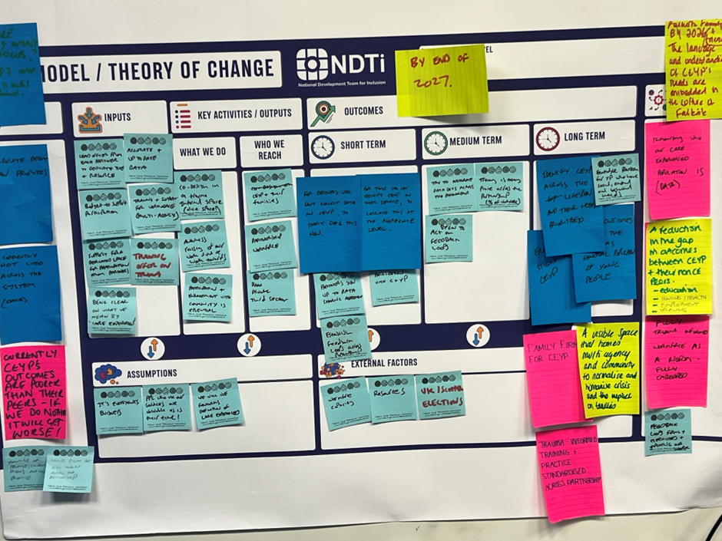

Appendix 2
Blank Copy of Promise Plan 21-24 Workforce Priorities Excel Sheet

Appendix 3
Falkirk Family and Friends Team Terms of Reference

The Falkirk Family and Friends Team
Terms of Reference Notes

- Purpose
The purpose of the Falkirk Family and Friends Team is to ensure that the gap is narrowed between the outcomes of looked after children and care experienced young people and those of their peers.

- Background
The Children and Young People (Scotland) Act 2014 defines corporate parenting as "the formal and local partnerships between all services responsible for working together to meet the needs of looked after children, young people and care leavers". A good corporate parent will want the best outcomes for their looked after children, accept responsibility for them, and make their needs a priority. The 2014 Act also introduced new duties and responsibilities for those Scottish public bodies defined as corporate parents, which came into effect in April 2015.

For some time, it has been known that the “care system” in Scotland needs to change. For over three years from 2016, the Care Review listened to care experienced children, young people, and families. In 2020, The Care Review set out, in a number of reports, how the country can make sure every care experienced child and young person reaches their full potential.

The Promise Scotland is an organisation that exists to support Scotland in keeping its promise to care experienced people - that they will grow up loved, safe, and respected.

The Falkirk Community Partnership has been awarded Whole Family Wellbeing Funding from the Scottish Government to facilitate change to Family Support Services. Using this funding a team has been established in Falkirk, The Promise Implementation Team, to carry out collaborative work over the next 3 years with partners to support and improve the effectiveness of Corporate Parenting and to Keep the Promise.

The Falkirk Family and Friends Team is being established so we can work together to improve the outcomes of looked after children and care experienced young people. The team were initially known as the Promise Corporate Parenting Partnership Group, but that name was formally changed after input from the Falkirk Champs Board in October 2023. The Champs members felt that the term ‘Corporate’ felt cold and business like and didn’t sit well with ‘Parenting’ which embodies the opposite feelings of being caring and warm. The group then unanimously agreed to change the name to Falkirk Family and Friends Team which it was felt, better reflected its work and ethos.

- Remit
The Corporate Parenting duties will apply to all looked after children (aged from birth to when they ceased to be looked after) and care leavers, who were looked after on or after their 16th birthday, up until the age of 26.
57 Application of Part: children and young people
(1) This Part applies to— Looked After
(a) every child who is looked after by a local authority, and
(b) every young person who—
(i) is under the age of 26, and
(ii) was (on the person's 16th birthday or at any subsequent time) but is no longer looked after by a local authority.
(2) This Part also applies to a young person who— Care Leavers
(a) is at least the age of 16 but under the age of 26, and
(b) is not of the description in subsection (1)(b)(ii) but is of such other description of person formerly but no longer looked after by a local authority as the Scottish Ministers may specify by order.

A child or young person is considered to be “looked after” if they fall into one of the categories set out in Section 17 (6) of the Children (Scotland) Act 1995, as amended by Schedule 2 of the Adoption and Children (Scotland) Act 2007. These categories are:
- Subject to a supervision requirement set by a Children's Hearing (including those on a compulsory supervision order and living at home with birth parents-‘looked after at home’)
- Accommodated by a local authority under Section 25 of the Children (Scotland) Act 1995 (otherwise known as a ‘voluntary agreement’)
- Subject to a permanence order granted by a court
- Subject to an order, authorisation or warrant made by relevant authorities under chapters 2,3 or 4 of Part 2 of the Children (Scotland) Act 1995
It is the duty of every corporate parent to,
- Be alert to matters which adversely affect the wellbeing of looked after children and care leavers
- Assess the needs of those children and young people for services and support it provides,
- Promote the interests of those children and young people,
- Seek to provide opportunities which will promote the wellbeing of looked after children and care leavers
- Take action to help children and young people access such opportunities and make use of the services and support provided
- Take any other action as it considers appropriate for the purposes of improving the way in which it exercises its functions in relation to looked after children and care leavers.
In addition,
- Work towards delivering The Promise

- Membership
Membership of the group must be representative of the Community Partnership

- 3rd Sector (Barnardo’s, Aberlour, etc.) (2)
- Falkirk Council (2)
- Police Scotland (1)
- Scottish Fire and Rescue (1)
- Forth Valley College (1)
- NHS Forth Valley (1)
- Children's Hearing Scotland (1)
- Falkirk Health & Social Care Partnership (1)
- Skills Development Scotland (1)
- Scottish Prison Service (1)
- Scottish Children's Reporters Administration (1)
- CHAMPS Board (1)

- Meetings
  - Chair
Meetings will be chaired by the Promise Coordinator for the Falkirk Community Partnership. This will be undertaken by the Promise Coordinator until 2026 when the role expires. At this point, the partnership will select a new permanent chair to take on the role. When unavailable another member of The Promise Implementation Team will step in to chair the meeting, if appropriate.

  - Guest Chair
Group members will be given the opportunity to chair meetings, if they are happy to do so.

  - Format
Meetings will take place in person, but where infrastructure allows, hybrid meetings will be offered to allow others to take part in meetings that could not attend otherwise.

All meetings will follow an agreed agenda, provided in advance, and be recorded in the form of a minute with a list of actions and action owners.

  - Admin Support
Admin support for the Group will be provided by the Customer and Business Support Officer from The Promise Implementation Team.

- Frequency of Network Meetings: The Group will meet a minimum every 8 weeks and can be scheduled more regularly, when required.

- Quorum: A minimum of 60% of members, comprising of representation from at least 5 areas and representation from Falkirk Champs Board, is required for a Falkirk Family and Friends meeting to legitimately take place.

- Reporting: The work of the Group will be reported twice a year to the Children and Young People’s Strategic Leadership Group.

- Review Terms of Reference: These terms of reference will be reviewed by the Group annually, to capture learning and ensure the remit and membership is still relevant.

Scottish Prison Service (2021) Vision for young people in custody 2021: using the time a young person spends in custody to prepare them for a positive future. Available at: http://www.sps.gov.uk/Corporate/Publications/Publication-7393.aspx (Accessed: 21 July 2023). ii Sanders, R. (2020) Care experinced children and young people’s mental health. Available at: https://www.iriss.org.uk/resources/outlines/care-experienced-children-and-young-peoples-mental-health (Accessed:26 July 2023).
iii Scottish Government (2022) Education outcomes for looked after children 2020/21. Available at: https://www.gov.scot/publications/education-outcomes-looked-children-2020-21/pages/3/ (Accessed: 24 July 2023).
i^{v} The Promise Oversight Board (2023) Report two. Available at: https://thepromise.scot/oversight-board/reports-and-minutes (Accessed: 21 July 2023).
^{v} Scottish Prison Service (2021) Vision for young people in custody 2021: using the time a young person spends in custody to prepare them for a positive future. Available at: http://www.sps.gov.uk/Corporate/Publications/Publication-7393.aspx (Accessed: 21 July 2023).

